CHIKKANNA GOVERNMENT ARTS COLLEGE
TIRUPUR-641602
(AFFILIATED TO BHARATHIAR UNIVERSITY)



TEAM MEMBERS NAME :
THAMARAI THAGAM.P(2022K0108)
VAISHALI.D(2022K0110)
ABINAYA.R(2022K0059)
VAISHNAVI(2022K0111)

DEPARTMENT OF COMPUTER SCIENCE

CHIKKANNA GOVERNMENT
ARTSCOLLEGE

NAAN MUDHALVAN PROJECT WORK

(AFFILIATED TO BHARATHIAR UNIVERSITY)
TIRUPUR-641602

TITLE :Optimizing Spam Filtering with Machine Learning.

This is to certify that this is a bonafide record of work done by the above students of III B.Sc (CS) Degree NAAN MUDHALVAN PROJECT during the year ……….

Submitted for the Naan Mudhalvan project work held
on………….20

CLASS TUTOR HEAD OF THE DEPARTMENT

INDEX

S.No. | Date | Contents | Page No.
1 |  | PROBLEM SELECTION
2 |  | IDEATION
3 |  | REQUIREMENT ANALYSIS
4 |  | PROJECT DESIGN
5 |  | PROJECT PALNNING PHASE
6 |  | PROJECT DEVELOPMENT PHASE
7 |  | RESULT(INPUT & OUTPUT)

PROBLEM SELECTION

1.False positives: This is when legitimate emails are incorrectly classified as spam and filtered out. This problem can be addressed by improving the accuracy of the spam filter and minimizing the number of false positives.
2.False negatives: This is when spam emails are not identified and end up in the inbox. This problem can be addressed by improving the sensitivity of the spam filter and minimizing the number of false negatives.
3.Evading spam filters: Spammers are constantly evolving their techniques to evade spam filters. This problem can be addressed by staying up-to-date with the latest spamming techniques and updating the spam filter accordingly.
4.User feedback: Users may sometimes mark legitimate emails as spam, or vice versa. This can lead to incorrect training of the spam filter and impact its performance. This problem can be addressed by developing a system for collecting and analyzing user feedback to improve the accuracy of the spam filter.
5.User feedback: Users may sometimes mark legitimate emails as spam, or vice versa. This can lead to incorrect training of the spam filter and impact its performance. This problem can be addressed by developing a system for collecting and analyzing user feedback to improve the accuracy of the spam filter.
IDEATION
1.Machine learning: Machine learning algorithms can be used to analyze large amounts of data to identify patterns and improve the accuracy of spam filtering. This can include techniques such as supervised and unsupervised learning, decision trees, and neural networks.
2.Natural Language Processing (NLP): NLP techniques can be used to analyze the text and language used in emails to identify spam. This can include techniques such as sentiment analysis, entity recognition, and part-of-speech tagging.
3.Sender reputation: A sender's reputation can be used to determine the likelihood that an email is spam. This can include factors such as the sender's IP address, domain, and history of spamming activity.
4.Blacklist and whitelists: Lists of known spam senders and legitimate senders can be used to filter emails. This can be updated regularly to ensure that the lists are accurate.
5.Content filtering: The content of emails can be analyzed to identify spam. This can include techniques such as checking for keywords commonly used in spam emails, analyzing the structure of the email, and checking for attachments and links.
6.User behavior: User behavior can be used to help identify spam. This can include techniques such as analyzing the frequency and timing of emails, identifying patterns in user behavior, and analyzing user feedback.
7.Hybrid approaches: Combining multiple techniques and approaches can improve the accuracy of spam filtering. For example, combining machine learning with NLP and content filtering can provide a more comprehensive approach to spam filtering.

REQUIREMENTS ANANLYSIS

1.Accuracy: The spam filter should have a high accuracy rate in detecting spam and avoiding false positives. This can be measured by metrics such as precision, recall, and F1 score.
2.Scalability: The spam filter should be able to handle large volumes of email and be scalable to handle increased volumes in the future.
3.Performance: The spam filter should operate quickly and efficiently to minimize any delay in email delivery.
4.User feedback: The spam filter should have a mechanism for collecting and analyzing user feedback to improve its accuracy and performance.
5.Flexibility: The spam filter should be flexible enough to adapt to changing spamming techniques and new types of spam.
6.Integration: The spam filter should be easy to integrate with existing email systems and tools, such as email clients and servers.

PROJECT DESIGN
1.Problem definition: Define the specific problem(s) to be addressed in spam filtering, such as reducing false positives, minimizing false negatives, or staying up-to-date with evolving spamming techniques.
2.Requirements gathering: Gather requirements for the spam filter, taking into account the considerations outlined in the requirement analysis section.
3.Data collection and preparation: Collect and prepare a dataset of emails, including both legitimate and spam emails. The dataset should be representative of the types of emails that the spam filter will encounter in the real world.
4.Algorithm selection and development: Select and develop algorithms for spam filtering, such as machine learning, NLP, and content filtering. Evaluate the performance of each algorithm using appropriate metrics and select the most effective approach.
5.Integration: Integrate the spam filter with existing email systems and tools, such as email clients and servers.
6.Deployment and monitoring: Deploy the spam filter in a production environment and monitor its performance and effectiveness over time. Continuously update the spam filter to keep up with evolving spamming techniques and address any issues that arise.

PROJECT PALNNING PHASE

1.Define the project scope: Clearly define the goals and objectives of the project, as well as the specific features and functionalities that will be included in the spam filter.
2.Identify the project team: Determine who will be involved in the project, including project managers, developers, data scientists, and other stakeholders.
3.Develop a project timeline: Create a timeline for the project, including key milestones and deadlines.
4.Allocate resources: Determine the resources that will be required for the project, including personnel, hardware, and software.
5.Identify potential risks: Identify potential risks that could impact the project, such as delays in data collection, algorithm development, or integration with existing email systems.

PROJECT DEVELOPMENT PHASE

1.Data collection and preparation: Collect a representative dataset of emails, including both legitimate and spam emails. Prepare the dataset for analysis, including cleaning and preprocessing.
2.Algorithm development: Develop and test algorithms for spam filtering, such as machine learning, NLP, and content filtering. Evaluate the performance of each algorithm using appropriate metrics and select the most effective approach.
3.Integration: Integrate the spam filter with existing email systems and tools, such as email clients and servers. Ensure that the spam filter is compatible with different email systems and can be easily integrated.
4.Testing and validation: Test and validate the spam filter using a separate dataset of emails, measuring the accuracy, performance, and scalability of the spam filter. Identify any issues or bugs and make necessary improvements.
5.Deployment: Deploy the spam filter in a production environment, ensuring that it is compatible with different email systems and can handle large volumes of emails.
6.User feedback and improvement: Collect and analyze user feedback to improve the accuracy and performance of the spam filter. Continuously evaluate the spam filter's performance and effectiveness and make adjustments as necessary.

RESULT

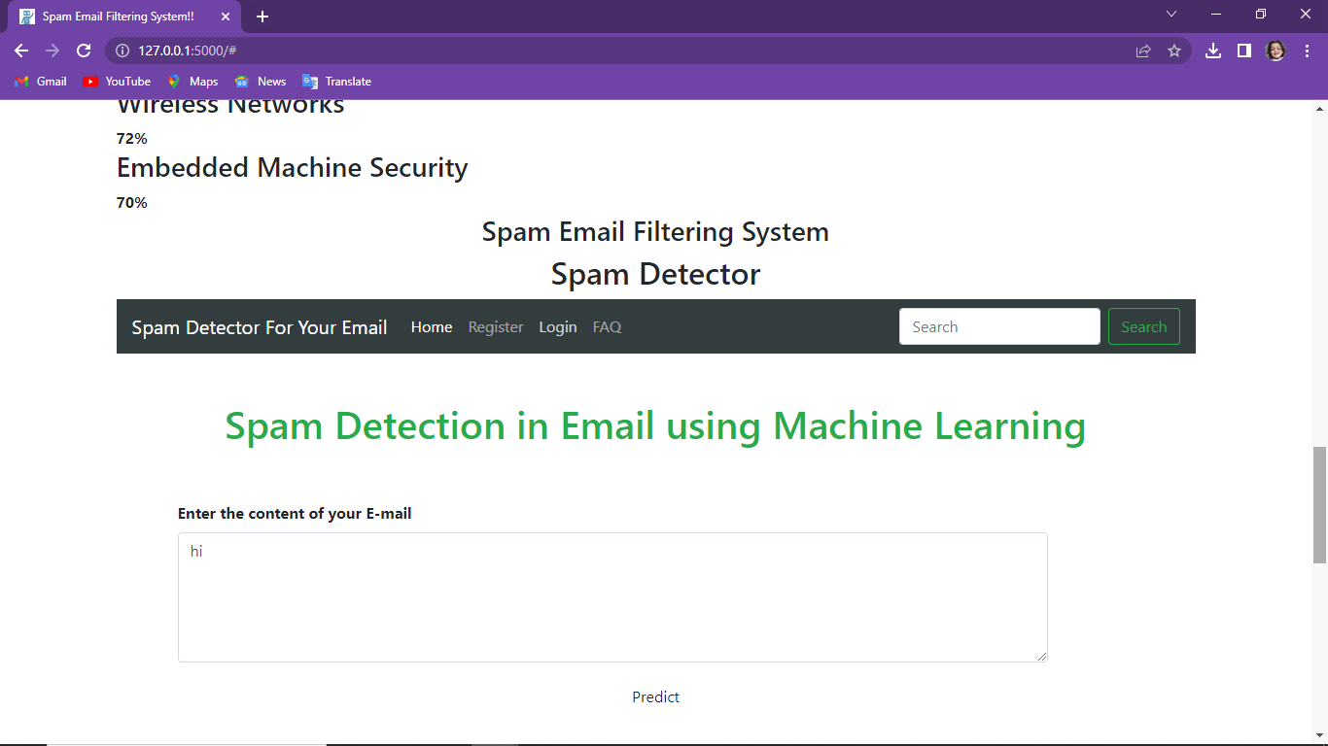

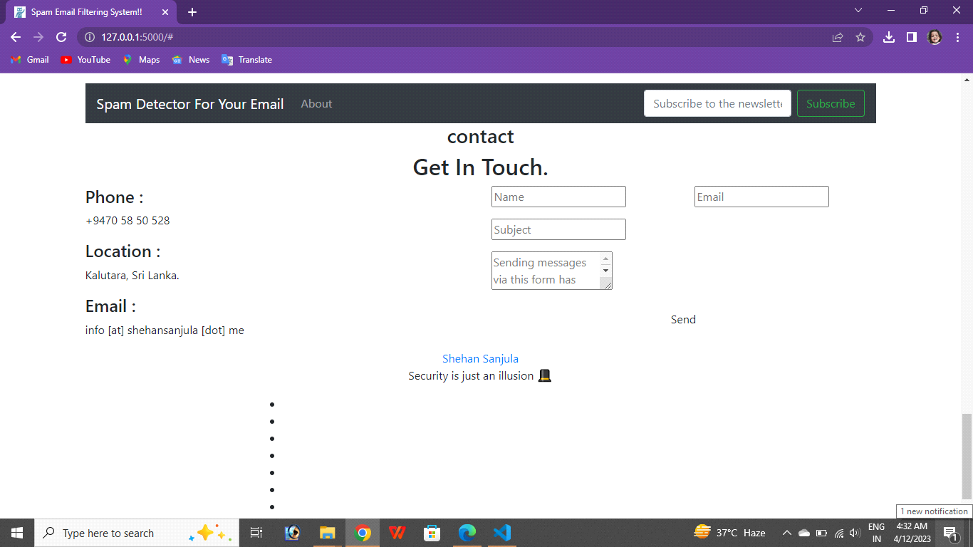

SAMPLE CODING

